Volume
Volume builds on concepts of length and area. We might start with an object (such as the rectangular prism, below:
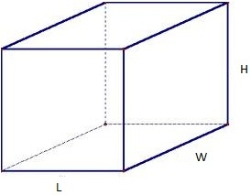
For an older kid, the idea of volume is straightforward – multiply the length by the width by the height and out pops volume.
Less obvious is why! Why does it work?
What is the mathematics that goes into the formula?
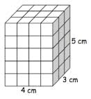
… and how does it tie into what kids already know?

We can use the diagram at left to illustrate some connections. We use the concept of length to get the measurement of each side. In our figure, these lengths are 4 cm, 3 cm, and 5 cm.

We ask kids to notice that our figure is made up of smaller blocks, just as they did with length and area. Volume becomes a “collection” of units. We want our kids to understand that VOLUME emerges from repeated AREA, just as area emerged from repeated lengths. The prism above is a stack of slices, each 4 x 3 (12 square units). We could just as easily lay it on its side and have a stack of 4 slices, each 3 x 5. No matter how we slice it, the volume is 60 cubes. If each cube measures a centimeter, we get 60 cm³!

Quick question: is this the only possible prism with a volume of 60?
Make a sketch or two with some other possibilities!
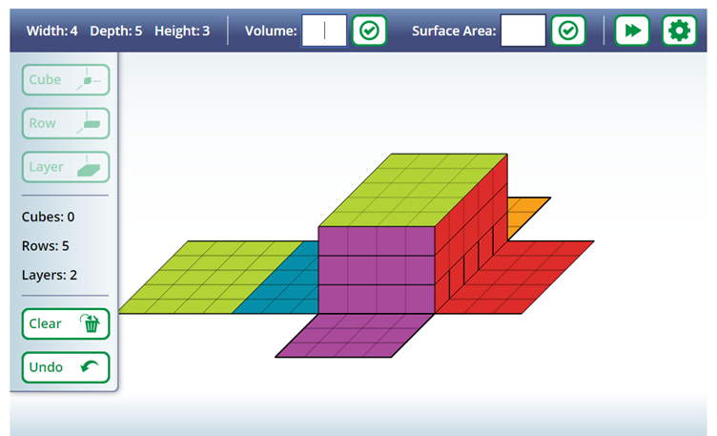
The National Council of Teachers of Mathematics (NCTM) puts together a number of activities that help illustrate math topics. I built our example digitally and took a screen shot (and then printed them in B&W and colored them in)!

Each of the colors offers a point of view and in our workshop, we’ll build our volume from each perspective. For instance, we can make five “slices of purple” that each have twelve blocks – that 5 x (4 x 3). Or perhaps we want three green slices – 3 x (4 x 5). Or four red slices of 15 blocks – 4 x (3 x 5).

There are tons of ways to explore math on the internet, but it often helps to have a few ‘go-to’ links. Your kids math teacher might have more, but here are a few to get you started:
Illuminations, NCTM: http://illuminations.nctm.org/
The link to the interactive I used is this one: http://illuminations.nctm.org/Activity.aspx?id=4095
Annenberg Learner also hosts a variety of visual lessons. This one is similar to one we just did together: http://www.learner.org/interactives/geometry/area_volume.html and there are many more.

Thanks for joining us at Math Madness! -- Greg

