Area
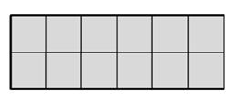
Second graders have repeated experiences forming rectangles with rows and columns of the same-size squares. They count the individual squares to find the total. These tiling experiences are the foundation for the area work which begins more formally in Grade 3.
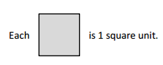

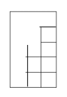
Third graders continue to tile rectangular regions, with no gaps and no overlaps, and learn the importance of using a standard square unit for measuring the inside region of a rectangle. Students have opportunities to complete rows and columns, or to make arrays of squares, to help build the concept of rectangular area.

They begin to link multiplication to finding area as they use the strategy of skip-counting to find the total number of tiles. Through these experiences, third graders learn to multiply side lengths to find the area of a rectangle and are able to represent and solve real world problems.
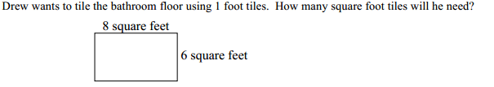

Third and fourth graders extend the concept of area to more complex figures. They learn that area is additive as they find ways to break larger shapes into smaller rectangles in order to find the area.
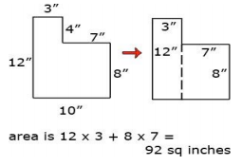

In fourth grade, students move from the generalization that you multiply the side lengths of a rectangle to find area to using a formula for the first time. Applying the formula A = l x w is a Common Core standard for fourth graders and is derived through all of the prior experiences students have had in order to build their deep understanding of this concept.

In fifth grade, the concept of area is crucial to supporting students’ understanding of volume. The students build on the idea of area as covering a space when they learn to cover the bottom of a rectangular prism with a layer of cube units to form the base. Then additional layers can be added on top of this original layer to model the volume of the 3-D solid.
